Experiment No. 8

Title: Device Features Integration in the GrocerySpot App

Theory:

Experimenting with device-specific features - Bluetooth and GPS

Integrating features like Bluetooth and GPS into my GrocerySpot app significantly enhances its functionality and provides users with valuable tools for navigating, communicating, and shopping efficiently. Let's explore how each feature enhances the user experience:

GPS Integration:
By integrating GPS functionality, my GrocerySpot app enables users to accurately determine their current location, find nearby grocery stores, view maps, and receive real-time navigation guidance to their selected stores. This feature is invaluable for shoppers seeking convenient access to groceries, helping them discover the nearest stores, navigate efficiently, and plan their shopping trips effectively within the app's intuitive interface.

Bluetooth Integration:
The inclusion of Bluetooth functionality in my GrocerySpot app opens up exciting opportunities for connectivity and interaction. Users can seamlessly pair their smartphones with Bluetooth-enabled devices, such as barcode scanners, payment terminals, or smart shopping carts, enhancing their shopping experience in various ways. For example, users can scan items with Bluetooth barcode scanners for quick checkout, make contactless payments using Bluetooth-enabled terminals, or receive personalized shopping recommendations based on their location within the store.

Experiment Implementation:
1. GPS Integration:
- Implement a feature that allows users to search for nearby grocery stores based on their current location.
- Display maps within the app to help users visualize store locations and plan their routes efficiently.
- Provide turn-by-turn navigation guidance to selected stores, integrating with popular mapping services.
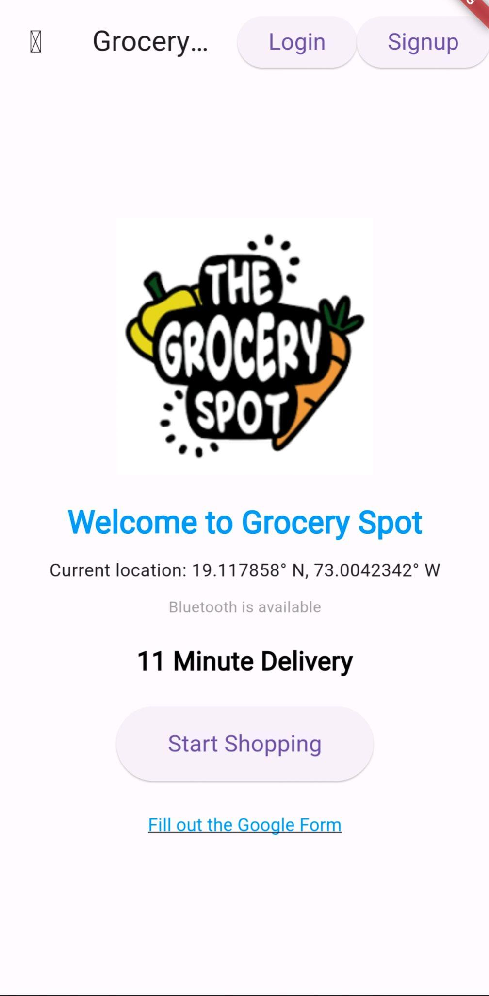

2. Bluetooth Integration:
- Enable Bluetooth pairing with compatible devices such as barcode scanners or payment terminals.
- Implement a feature for contactless payments using Bluetooth-enabled payment terminals for a seamless checkout experience.
- Integrate Bluetooth connectivity with smart shopping carts to provide users with personalized recommendations and in-store navigation assistance.

3)Shake Detection Functionality:
- Introduce shake detection functionality to elevate accessibility and user interaction.
- Implement shake-based commands for navigating product categories, scrolling through lists, and accessing menus.
- Ensure responsive adaptation of the interface elements in response to device shaking, delivering a fluid and intuitive shopping experience.
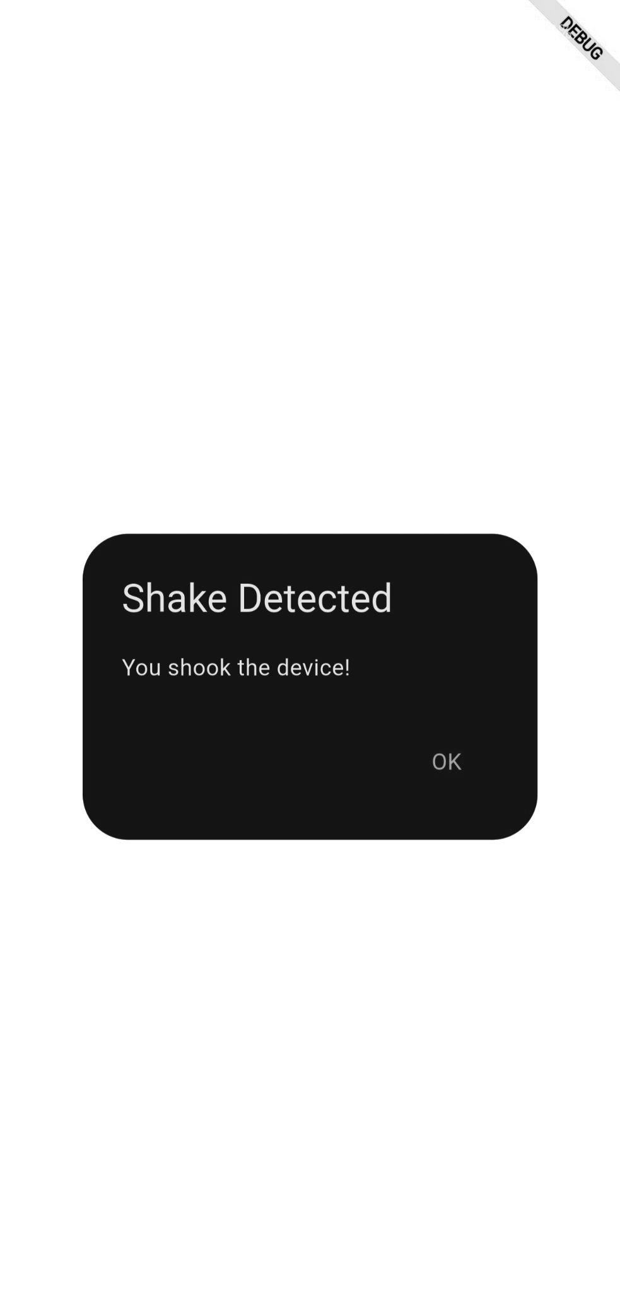

Conclusion:
Integrating GPS and Bluetooth functionality into the GrocerySpot app provides users with valuable tools for navigating, communicating, and shopping efficiently. GPS integration enables users to find nearby grocery stores and navigate to their selected stores with ease, while Bluetooth integration enhances connectivity and interaction with Bluetooth-enabled devices for quick checkout and personalized shopping experiences. Additionally, implementing tilt control introduces an innovative and user-friendly feature that enhances accessibility and improves the user experience, ensuring that users can shop conveniently and independently within the app's intuitive interface.

